Location Map

For the location of the proposed design of coal-powered power plant, three municipalities in Batangas were considered: Calatagan, Lian and Nasugbu. Each chosen areas are located near bodies of water which are important as a source for plant operations. The location in Calatagan however, seemed to conflict with the type of land the municipality has since nowadays, people require more agricultural crops to supplement the increasing demand of the country. This narrows the options to Lian and Nasugbu. For both options, Nasugbu seemed to conflict with the neighboring commercial resorts as it would affect their business and the type of land the municipality has. Therefore, it was concluded that the location in Lian is the most applicable option among the three. Even if the location in Lian needs additional labor to flatten the land which is elevated by 70 m, it is chosen since it has a commercial type of land and can also be easily reached in road transportation. Several parameters were also considered in comparing the three possible locations.

**Table 1**

**Comparison of Parameters of the Three Locations**

|  |  |  |  |
| --- | --- | --- | --- |
| **Parameters** | **Location 1**  **Calatagan** | **Location 2**  **Lian** | **Location 3**  **Nasugbu** |
| Surrounding bodies of water | Present | Present | Present |
| Topography | Elevated | Elevated | Flat |
| Nearness of the load center | Near | Near | Near |
| Road Transportation | Easy | Easy | Easy |
| Type of land | Agricultural | Commercial | Agricultural |
| Disturbances | Many resorts | Forestation | Many resorts |

Table 1 shows the different parameters used to determine the plant location. All of the locations are strategically located near bodies of water. The location in Calatagan is located along the coast of Pagaspas Bay and the location in Lian and Nasugbu are both located along Nasugbu Bay. All of the locations are open areas for the construction of large facilities.

The researchers decided to install the proposed power plant in Brgy. Lumaniag, Lian, Batangas due to its strategic location with regards to the availability of sources of water, nearness to the load center, road transportation, type of land and fuel transport via sea. The chosen location will provide electricity to the different municipalities in the province of Batangas.

Lian, officially the Municipality of Lian, is a 3rd class municipality in the province of Batangas, Philippines. It is also a coastal municipality of the province. According to the 2015 census, it has a population of 52,660 people. The municipality is located in the northwestern part of Batangas Province and bounded on the north by the Municipality of Nasugbu; on the east by the Municipalities of Tuy and Balayan, on the west by South China Sea and on the south by the Municipality of Calatagan.  It is geographically situated at 120 degrees 39’ longitude and 14 degrees 12’ latitude. The municipality has a land area of 76.80 square kilometers which constitutes 2.46% of Batangas’ total area. It is also located between BATELEC I in Calatagan and BATELEC I Substation in Nasugbu.

Brgy. Lumaniag is located along the coast of Nasugbu Bay. In 2015 census, its population was determined as 2,309 which constitutes 4.38% of the total population of Lian. The specific location of the power plant is at 14°00”42’ North and 120°37”07’ East of the Philippines.

Below is the proposed plant location located at Brgy. Lumaniag, Lian, Batangas.

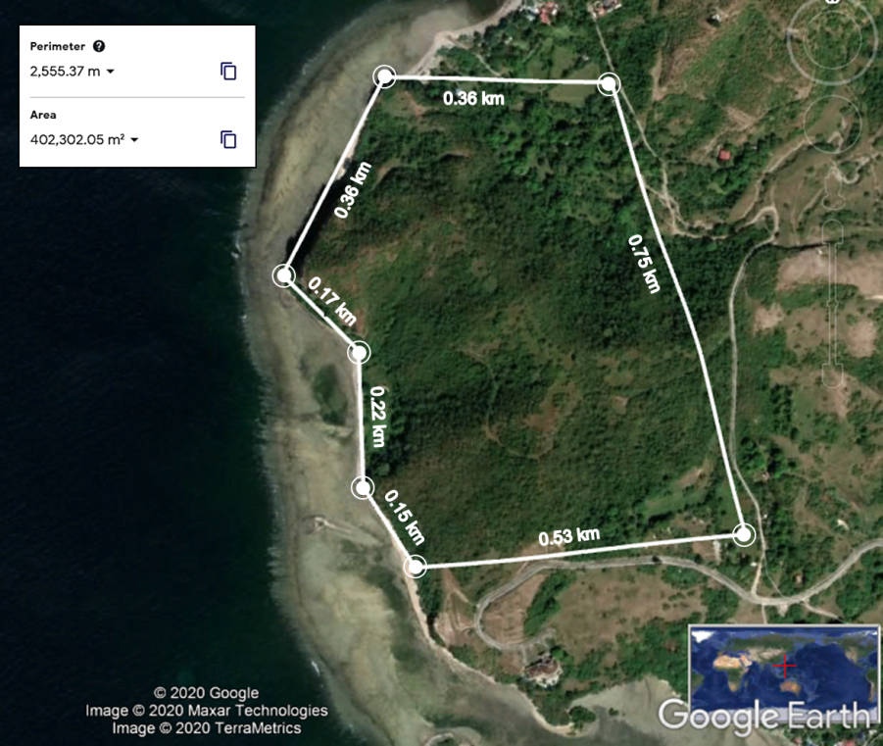

**Figure 2.** Proposed Location of the Coal-Fired Power Plant (Google Earth, 2020)

Figure 2 shows the location of the proposed plant site. The proposed coal-fired power plant is to be located in Brgy. Lumaniag, Lian, Batangas.

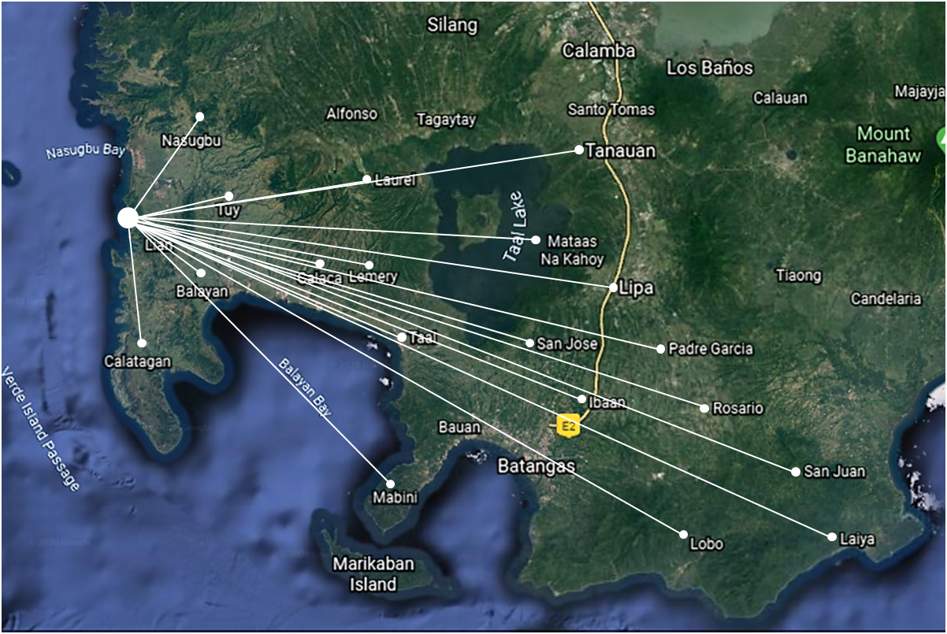

**Figure 3.** Plant location showing the target municipalities in the province of Batangas (Google Earth, 2020)

Figure 3 shows the target municipalities to be supplied by the proposed coal-fired power plant in Lian, Batangas. Its primary purpose is to provide energy for the province of Batangas with the help of the distribution units of BATELEC I, BATELEC II, First Bay Power Corporation (FBPC) and Ibaan Electric Engineering Corporation (IEEC). BATELEC I distributes electricity in the municipalities of Nasugbu, Lian, Calatagan, Balayan, Tuy, Lemery, Calaca, Agoncillo, San Nicolas, Sta. Teresita and San Luis. BATELEC II distributes electricity to the municipalities of Laurel, Talisay, Tanauan, Malvar, Balete, Lipa, Cuenca, San Jose, Alitagtag, Mabini, Tingloy, Padre Garcia, Rosario, Lobo, San Juan and Taysan. The additional power produced can be distributed also in some areas in Manila that are connected to the Luzon Grid such as MERALCO. Some articles has shown that Luzon grid is in need of around 491 MW in order to stabilize the grid and maintain power to support the grid.